

**International School**

**Capstone Project 1**

CMU-SE 450

**User Interface Design Document**

**Version 1.0**

**Date: 23/9/2021**

**SConA – School Connect Application**

**Submitted by**

Nguyen Thanh Phu

Nguyen Trung Hieu

Dang Nguyen Bao Hoai

**Approved by**

Nguyen Minh Nhat

**Project Information**

|  |  |  |  |  |
| --- | --- | --- | --- | --- |
| **Project acronym** | SConA | | | |
| **Project Title** | School Connect Application | | | |
| **Start Date** | 22-Aug-2021 | **End Date** | | 18-Dec-2021 |
| **Lead Institution** | International School, Duy Tan University | | | |
| **Project Mentor & contact details** | Name: Nguyen Minh Nhat  Email: nhatnm2010@gmail.com  Tel: +84 905 125 143 | | | |
| **Scrum Master & contact details** | Name: Nguyen Thanh Phu  Email: [thangphu104@gmai.com](mailto:thangphu104@gmai.com)  Tel: +84 772 492 301 | | | |
| **Team members** | **Name** | **Email** | **Tel** | |
| Nguyen Trung Hieu | hnguyentrung20@gmail.com | +84 975 299 149 | |
| Dang Nguyen Bao Hoai | dangbhoai@gmail.com | +84 773 305 395 | |

|  |  |  |
| --- | --- | --- |
| **Document History** | | |
| **Version** | **Date** | **Comments** |
| V1.0 | 01/09/2021 | Create User Interface Design Document |
|  |  |  |
|  |  |  |
|  |  |  |

**TABLE OF CONTENTS**

**1.** **Introduction** 3

**1.1.** **Purpose** 3

**1.2.** **Scope** 3

**2.** **Describe User Interface Application in Detail** 3

**2.1.** **UI-01: Login** 3

**2.2.** **UI-02: Home** 4

**2.3.** **UI-03: Logout** 6

**2.4.** **UI-04: Account Managerment** 7

**2.5.** **UI-05: Add Account** 8

**2.6.** **UI-06: Update Account** 9

**2.7.** **UI-07: Forum Managerment** 11

**2.8.** **UI-08: Add Forum** 12

**2.9.** **UI-09: Update Forum** 13

**2.10.** **UI-10: Dashboard** 14

# 

# **Introduction**

# **Purpose**

* This document describes the design interface of “School Connect Application” System.

# **Scope**

* Create complete interfaces, and describe them clearly.
* Overview of the stages and modules of the system.

# **Describe User Interface Application in Detail**

# **UI-01: Login**

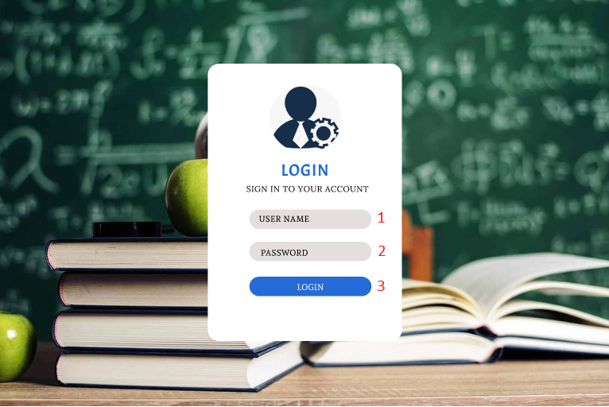

|  |  |  |  |  |
| --- | --- | --- | --- | --- |
| **ID** | **Condition** | **Control Type** | **Target** | **Notes** |
| 1 | Input | Textbox | Input username |  |
| 2 | Input | Textbox | Input user’s password |  |
| 3 | Click | Button | Click to login into the system |  |

# **UI-02: Home**

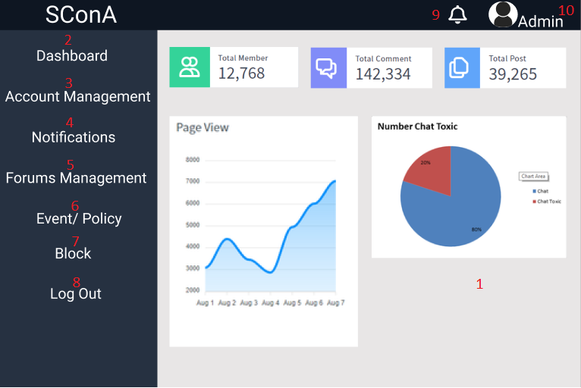

|  |  |  |  |  |
| --- | --- | --- | --- | --- |
| **ID** | **Condition** | **Control Type** | **Target** | **Notes** |
| 1 | View | Section | Display the number of users, comment, the post in the system and show chart |  |
| 2 | Click | Button | Click to go to dashboard |  |
| 3 | Click | Button | Click to go to account managerment |  |
| 4 | Click | Button | Click to go to home notifications |  |
| 5 | Click | Button | Click to go to forums managerment |  |
| 6 | Click | Button | Click to go to event/ policy |  |
| 7 | Click | Button | Click to go to block |  |
| 8 | Click | Button | Click to logout the system |  |
| 9 | Click | Button | View Notification |  |
| 10 | View | Section | View name user |  |

# **UI-03: Logout**

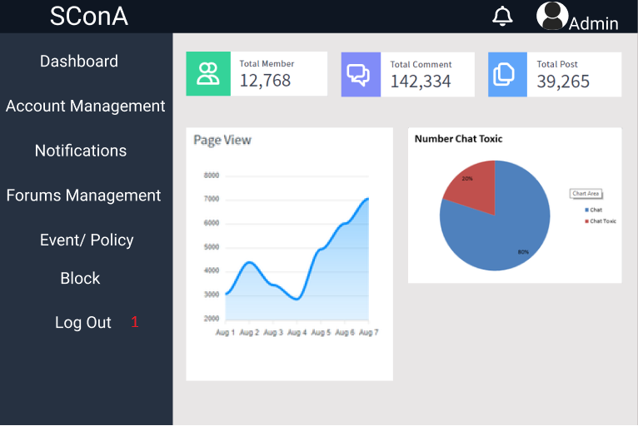

|  |  |  |  |  |
| --- | --- | --- | --- | --- |
| **ID** | **Condition** | **Control Type** | **Target** | **Notes** |
| 1 | Click | Button | Click to logout the system |  |

# **UI-04: Account Managerment**

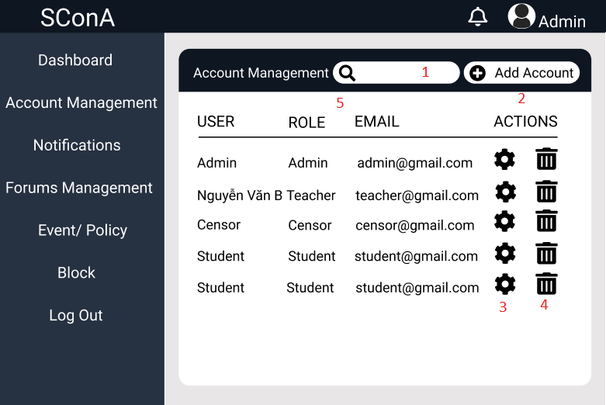

|  |  |  |  |  |
| --- | --- | --- | --- | --- |
| **ID** | **Condition** | **Control Type** | **Target** | **Notes** |
| 1 | Input | Textbox | Search user’s account |  |
| 2 | Click | Button | Click to create new the user’s account |  |
| 3 | Click | Button | Click to view and update the user’s account information |  |
| 4 | Click | Button | Click to delete the user’s account |  |
| 5 | View | Table | View all the user’s account |  |

# **UI-05: Add Account**

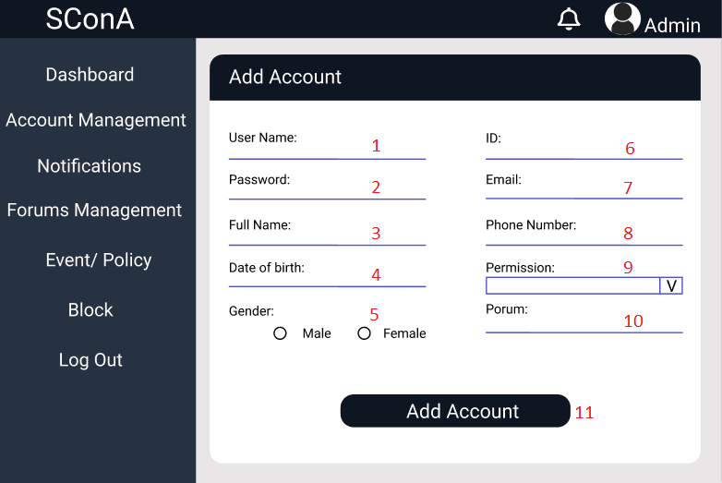

|  |  |  |  |  |
| --- | --- | --- | --- | --- |
| **ID** | **Condition** | **Control Type** | **Target** | **Notes** |
| 1 | Input | Textbox | Input the username |  |
| 2 | Input | Textbox | Input the password |  |
| 3 | Input | Textbox | Input the full name |  |
| 4 | Input | Textbox | Input the date of birth |  |
| 5 | Radio | Select | Choose the gender |  |
| 6 | Input | Textbox | Input the id |  |
| 7 | Input | Textbox | Input email |  |
| 8 | Input | Textbox | Input the phone number |  |
| 9 | Combobox | Select | Choose the user permission |  |
| 10 | Input | Textbox | Input the forum name if account is censor |  |
| 11 | Click | Button | Click to add account |  |

# **UI-06: Update Account**

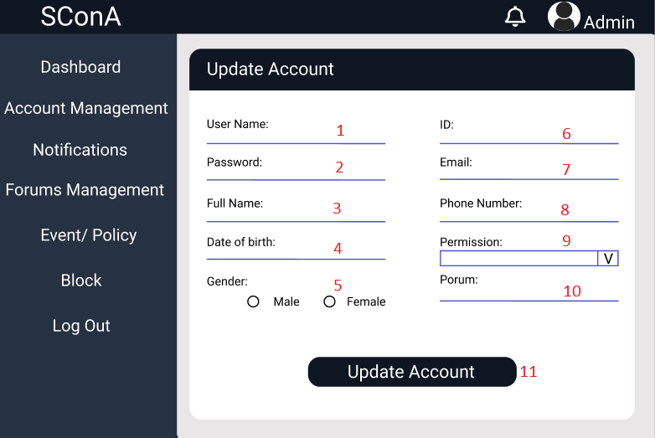

|  |  |  |  |  |
| --- | --- | --- | --- | --- |
| **ID** | **Condition** | **Control Type** | **Target** | **Notes** |
| 1 | Input | Textbox | Input the new username |  |
| 2 | Input | Textbox | Input the new password |  |
| 3 | Input | Textbox | Input the new full name |  |
| 4 | Input | Textbox | Input the new date of birth |  |
| 5 | Radio | Select | Choose the new gender |  |
| 6 | Input | Textbox | Input the new id |  |
| 7 | Input | Textbox | Input the new email |  |
| 8 | Input | Textbox | Input the new phone number |  |
| 9 | Combobox | Select | Choose the new user permission |  |
| 10 | Input | Textbox | Input the new forum name if account is censor |  |
| 11 | Click | Button | Click to update account |  |

# **UI-07: Forum Managerment**

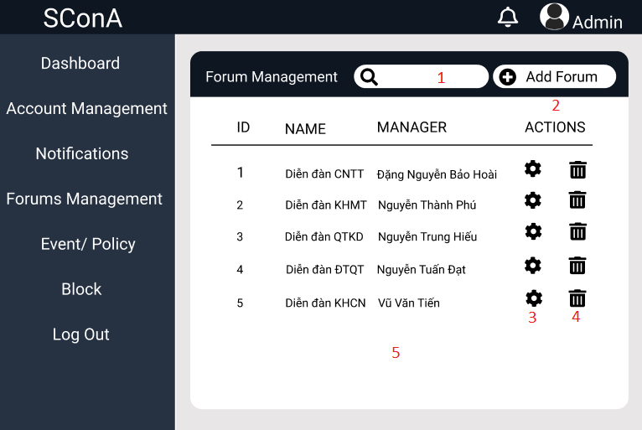

|  |  |  |  |  |
| --- | --- | --- | --- | --- |
| **ID** | **Condition** | **Control Type** | **Target** | **Notes** |
| 1 | Input | Textbox | Search forum |  |
| 2 | Click | Button | Click to create new the forum |  |
| 3 | Click | Button | Click to view and update the forum information |  |
| 4 | Click | Button | Click to delete the forum |  |
| 5 | View | Table | View all the forum |  |

# **UI-08: Add Forum**

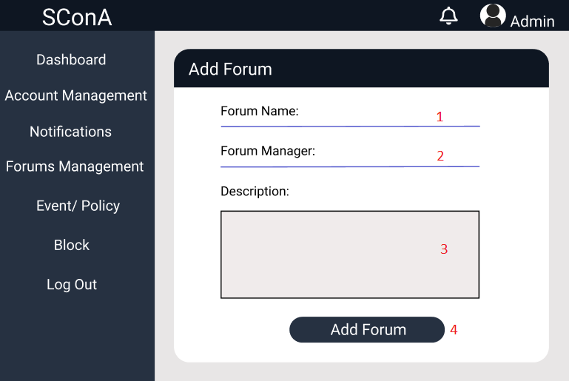

|  |  |  |  |  |
| --- | --- | --- | --- | --- |
| **ID** | **Condition** | **Control Type** | **Target** | **Notes** |
| 1 | Input | Textbox | Input the forum name |  |
| 2 | Input | Textbox | Input the forum manager |  |
| 3 | Input | Textarea | Input the description |  |
| 4 | Click | button | Click to add forum |  |

# **UI-09: Update Forum**

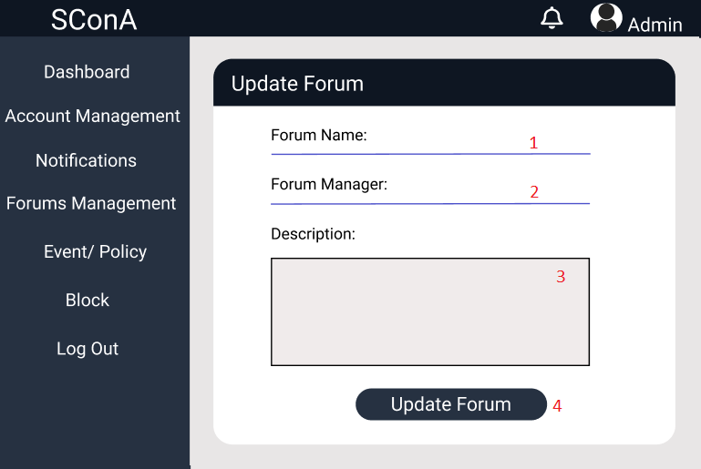

|  |  |  |  |  |
| --- | --- | --- | --- | --- |
| **ID** | **Condition** | **Control Type** | **Target** | **Notes** |
| 1 | Input | Textbox | Input the new forum name |  |
| 2 | Input | Textbox | Input the new forum manager |  |
| 3 | Input | Textarea | Input the new description |  |
| 4 | Click | button | Click to update forum |  |

# **UI-10: Dashboard**

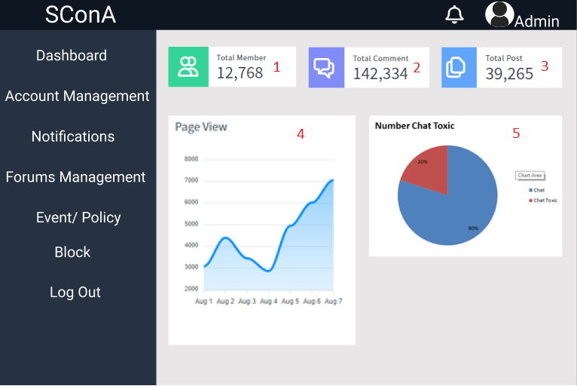

|  |  |  |  |  |
| --- | --- | --- | --- | --- |
| **ID** | **Condition** | **Control Type** | **Target** | **Notes** |
| 1 | Nothing | Label | Show total number account |  |
| 2 | Nothing | Label | Show total number comment |  |
| 3 | Nothing | Label | Show total number the post |  |
| 4 | Nothing | Chart | Show Chart about page view |  |
| 5 | Nothing | Chart | Show Chart about number chat toxic |  |